
Circe Invest's Fiona Frick: Investing in a world on edge
Investors forced to reassess exposures
Fiona Frick
11 April 2025 • 5 min read
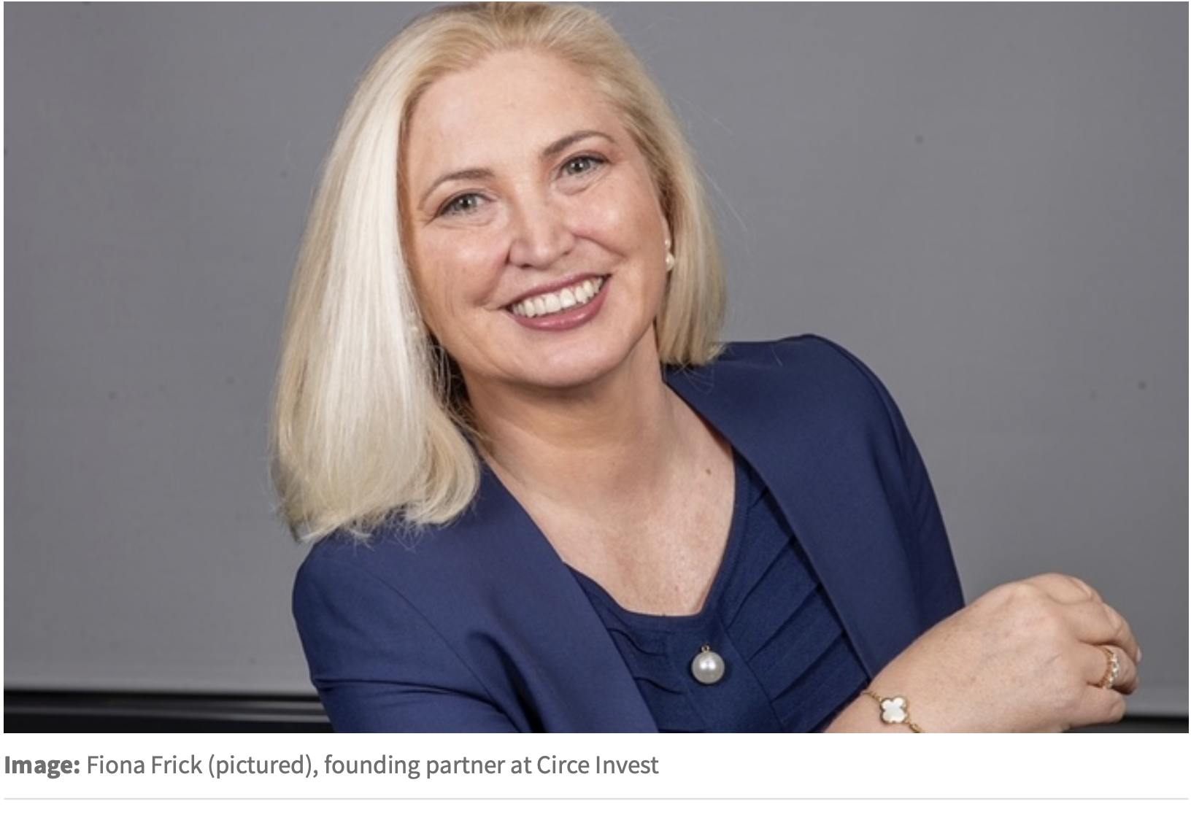
Geopolitical volatility is redrawing the boundaries between defence and sustainability in investment strategy.
US President Donald Trump's renewed rhetoric on annexing Greenland and Canada, alongside Vice President JD Vance's combative speech at the Munich Security Conference accusing European leaders of undermining free speech and democracy, have shaken longstanding assumptions about transatlantic security.
In response, Europe is accelerating efforts to rearm and reduce dependency on the US military umbrella.
This shift is prompting a reassessment of ESG frameworks that have historically excluded defence investments. Once deemed ethically incompatible, defence stocks are now being reconsidered as essential to preserving democratic stability and global order.
Babcock to replace Hargreaves Lansdown in the FTSE 100 as defence focus intensifies
Simultaneously, the Democratic Republic of Congo (DRC), which supplies around 70% of the world's cobalt, is facing escalating conflict, including rebel advances and the rise of a new insurgent group led by war criminal Thomas Lubanga, disrupting mining operations and raising serious concerns over supply chain security and human rights.
As geopolitical and sustainability risks increasingly overlap, investors are being forced to reassess exposure and adapt strategies.
Europe's defence pivot
Europe is undergoing a significant security realignment, as questions grow over the long-term reliability of US support for NATO.
Poland now spends over 4% of GDP on defence, while countries like Italy and Spain remain below NATO's 2% target.
In response, the EU is expanding its military capabilities - boosting domestic arms production, advancing cybersecurity and investing in defence technology.
The European Commission's ReArm Europe plan seeks to mobilise €800bn over four years to reinforce these efforts. Companies such as BAE Systems, Thales and Rheinmetall have benefited from this shift, reflecting growing investor interest in the sector.
In the UK, over 100 Labour MPs and peers have called for a reassessment of ethical investment rules, arguing that national security should not be seen as incompatible with responsible finance.
FCA's sustainability rules 'do not prevent investment' in defence companies
Germany's Christian Democratic Union has made similar proposals, suggesting ESG frameworks may
need to evolve in light of changing geopolitical realities.
Meanwhile, new financing instruments are emerging. The European Investment Bank (EIB) is lifting restrictions on defence funding, and proposals like special adviser to the president of the European Commission Sauli Niinistö's Safer Together call for allocating 20% of the EU budget to security and crisis preparedness, with the EIB helping to crowd in private capital through socially-labelled bonds and cybersecurity investments.
As Europe redefines its security strategy, the investment community faces difficult questions. Can defence coexist with ESG principles? Must sustainability frameworks adapt to include resilience and security?
There are no simple answers but the conversation is no longer avoidable

Portfolio exposure
In 2025, geopolitical instability has severely impacted the supply of critical raw materials essential for the climate and digital transitions.
A series of conflicts across key producing nations have disrupted access to minerals like cobalt, rare earths, tin and gold - vital for clean energy technologies and digital infrastructure.
In the DRC, which provides over 60% of the world's cobalt, the government suspended exports for four months following a steep price drop.
WisdomTree launches European defence ETF amid heightened calls for higher military spending
Given cobalt's role in electric vehicle batteries and energy storage, the move sparked global concerns about supply shortages and price volatility. At the same time, rebel advances in eastern Congo have led
to further mining disruptions, especially in the tin sector.
Myanmar, another strategic resource hub, has seen heavy rare earth supplies plummet after the Kachin Independence Army seized key mining zones. Meanwhile, illegal gold mining has surged, funding armed groups and causing environmental damage.
These developments expose the fragility of global supply chains and emphasise the need for diversified, ethically sourced and geopolitically resilient mineral strategies to support the green and digital transformations.
Investing in security and stability
As geopolitical risks intensify, investors face a dual challenge: aligning with Europe's expanding defence agenda while managing exposure to fragile, conflict-affected regions.
Defence is increasingly seen as essential to national security, with rising allocations to aerospace, cybersecurity and military technology. EU-backed innovation programmes and long-term contracts are enhancing the investment case for European defence firms.
This strategic pivot, however, challenges traditional ESG frameworks. Historically, many ESG funds excluded defence on ethical grounds, particularly due to its association with armed conflict.
While EU regulations prohibit investment in controversial weapons, there is no blanket ban on conventional or nuclear defence companies. Still, reputational risk and conservative interpretations have kept many funds cautious.
Ukraine war has made City spending on defence 'essential' as opposed to 'contentious'
By the end of 2024, European asset managers had raised their average defence allocation to 1.1%, while ESG funds increased exposure modestly to 0.5%. Over 1,200 ESG funds now include defence holdings, signalling a gradual shift toward engagement over exclusion.
This shift also extends to risk management. Companies sourcing from fragile states face heightened exposure to resource nationalism, regulatory volatility and supply chain disruption.
Tools like the Fragile States Index and frameworks from TrustWorks help quantify and manage these risks. Even companies headquartered in stable markets can be vulnerable due to their reliance on conflict-prone suppliers.
Rather than divesting from high-risk areas, many investors are pursuing active ownership - pushing for responsible sourcing, transparency and local community investment.
In parallel, modern defence technologies, such as AI, cybersecurity and crisis resilience, are attracting private equity and venture capital.
Navigating this evolving landscape requires a balanced approach: integrating security concerns into ESG analysis while building resilient, ethically grounded portfolios.
The future of sustainable investing may depend not on avoiding complexity but on managing it with foresight and accountability.
Fiona Frick is founding partner at Circe Invest


